

**Home School Agreement Child’s Name…………………….…………**

*We are very proud of our Home School Agreement since we truly believe it reflects the ethos and aims of our school. We must sign it on behalf of the school, and parents / carers and their children are invited to sign it.*

**The school will do its best to:**

Promote learning as interesting and enjoyable. Finding ways in which to inspire children to achieve.

Promote a child centred approach to education that involves and motivates children and seeks to develop a positive self-esteem.

Make sure your child tries hard and is encouraged to do his / her best and celebrate the success of all children.

Offer a broad and balanced curriculum which meets the needs of your child including the setting of home learning opportunities.

Develop pupils’ independence, motivation and self-discipline (resilience).

Care for pupils’ safety and happiness.

Achieve high standards in learning and behaviour and work with you if we are concerned about your child’s learning or behaviour.

Provide relevant information about school matters and pupils’ progress.

Listen and respond promptly to any concerns you express.

Be open and welcoming and offer opportunities for parents to become involved in the life of our school.

Welcome all members of the school community – staff, children, parents and governors – with respect and politeness.

**Children: I will try to…**

Do my best in all areas of school life.

Enjoy school and look for interest in all I do.

Ask questions and share my thinking with others.

Do my best to learn and make sure I do not interrupt the learning of other children.

Be kind, friendly and polite at all times.

Follow the school’s Rules.

Respect other people and property.

To do as I am asked by the staff.

Talk at home about my learning at school.

Wear the school uniform.

Talk to staff if I am unhappy or need help.

**Parents / Carers will try to …**

Take an interest in my child’s learning and promote the joy of learning through discussion and support.

Support my child in home learning activities especially regular reading.

Develop my child’s sense of responsibility, self-discipline and independence.

Treat all members of the school community – staff, children, parents and governors – with respect and politeness.

Support the school’s policies and procedures including the behaviour and uniform policies.

Make sure my child attends school regularly, arrives and leaves on time.

Inform the school on the first day of absence and provide evidence if necessary.

Inform the school of any issues at home that may affect my child’s learning or behaviour.

Attend parents’ evenings and take an interest in my child’s progress.

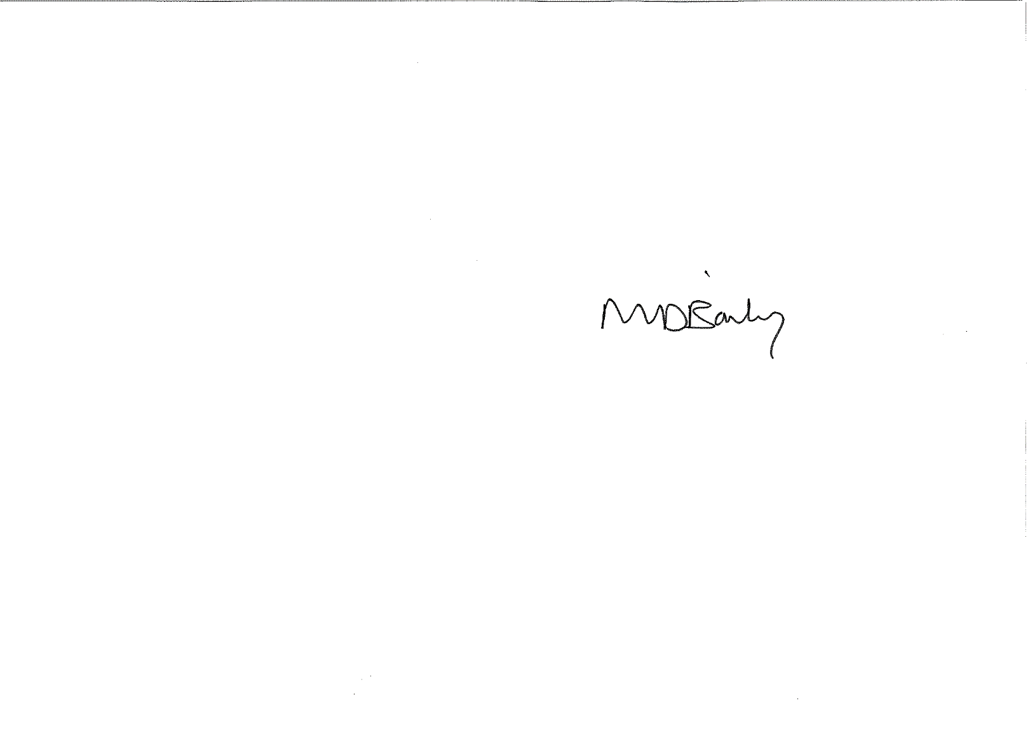

**Signed by Head Teacher: ………………….…………….…..…… Date: May 2020**

**Signed by Parent / Carer: …………………….………..………… Date: …………………………**

**Signed by Child ……………………………….……………………….. Date: …………………………**